Ideation Phase
Empathize & Discover

Date | 17 March 2025
Team ID | SWTID1744544274
Project Name | Book-Store
Maximum Marks | 4 Marks

Empathy Map Canvas:

THINKS
- "I need affordable books, especially for college."
- "I hope the reviews are trustworthy."
- "Will this book arrive on time before my exams?"
- "I wish I could see similar books like on Amazon."
- "How do I know which book is the latest edition?"

👀 SEES
- Long lists of books without proper filters
- Confusing product pages with poor layout
- Limited or no personalization on other book websites
- No clear indicators of book availability or edition
- Complicated checkout processes

🗣️ SAYS
- “Why is there no wish list to save books for later?”
- “This site is not mobile-friendly at all!”
- “I want to compare prices with other stores.”
- “I love it when there’s a good recommendation engine.”
- “Why can’t I pay via UPI or wallet?”

👂 HEARS
- Friends recommending e-commerce apps with fast delivery
- Influencers/bloggers reviewing books on Instagram/YouTube
- Classmates discussing where to get the cheapest edition
- Parents asking if the site is trustworthy

💖 FEELS
- Excited to buy new books
- Frustrated by slow websites and poor filtering
- Anxious about late delivery or payment failure
- Annoyed when books go out of stock before she can buy
- Relieved when checkout and delivery are smooth

🎯 DOES
- Searches book titles directly on Google or YouTube
- Uses filters if available to refine search
- Adds books to cart and compares prices
- Reads reviews and delivery ratings
- Prefers digital payment and UPI options
- Sometimes abandons cart if checkout is hard

🌟 PAINS (Frustrations/Challenges)
- Poor navigation and unresponsive design
- Limited payment methods
- No tracking or estimated delivery date
- Hard to find academic book editions
- Inability to save and return to books

🌈 GAINS (User Goals/Needs)
- Fast, easy-to-use website
- Book previews, reviews, and recommendations
- Discounts or coupons for students
- Easy reordering and purchase history
- Multiple secure payment options (UPI, wallet, card)

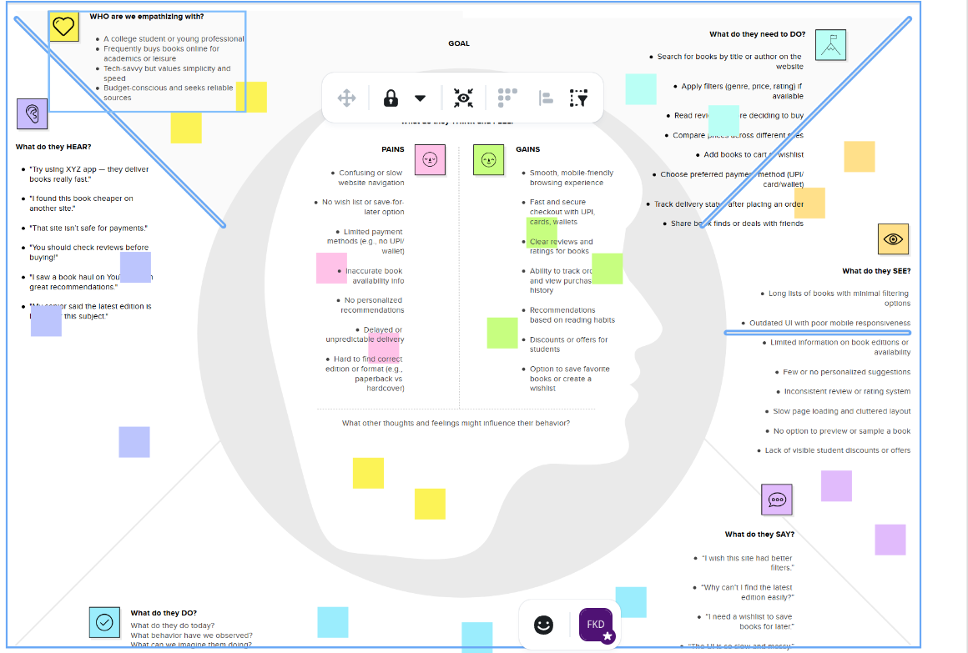
Book-Store

